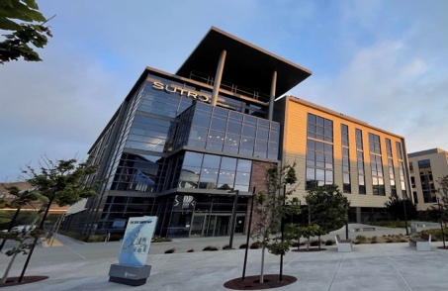
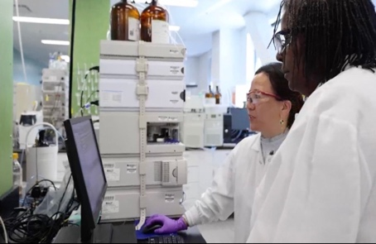
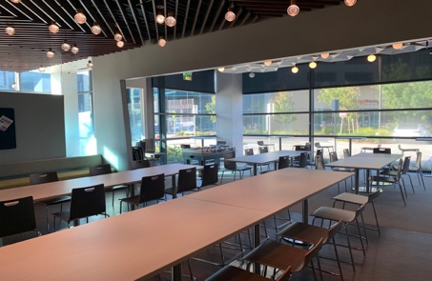
the San Francisco Bay Area.
Welcome to Sutro Biopharma
Corporate Office
Ground Transportation
Hotel Recommendations
The most efficient mode of
transportation to the
Premium Hotel
We currently have two locations in

This guide provides you with beneficial information for your visit
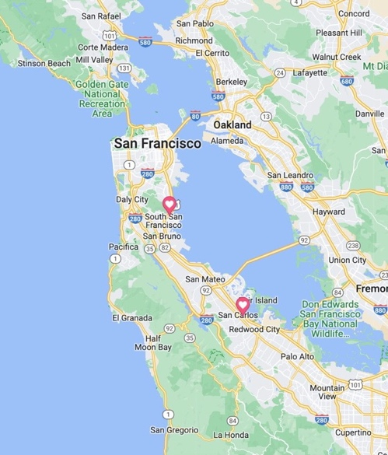

Sutro Biopharma Corporate Office

Sutro Biopharma Manufacturing Office

Location and Address Corporate Office:
Sutro Biopharma
111 Oyster Point Blvd
South San Francisco, CA 94080 USA
Phone: 650-881-6500
Fax: 650-553-9659
E-Mail: Visitors@sutrobio.com

Traveling by Plane
San Francisco International Airport which is located approx. 4.5 miles from Sutro South San Francisco via Highway 101 North.
corporate office are Uber, Lyft and Taxis.

Driving Directions
Whether you’re coming northbound or southbound you will have immediate access to Sutro from US-101 Freeway. Other transit options include direct shuttle service to BART, Caltrain and the Bay Ferry Service. The parking garage located at 101 Oyster Point BLVD is free and available to all.
24/7 security to help escort visitors to their vehicle. Please call 650-642-8160.

Nearby Restaurants
Foundry & Lux – Modern café, coffee bar, casual dining room, and lounge.

Nick the Greek –Authentic Greek street cuisine.

Starbucks – Coffee bar, fresh salads, sandwiches and snacks.

The Sandwich Spot – Creative made-to-order sandwiches.

Traverse – Coffee bar and food hall using local-source ingredients with a diverse array of every-changing international flavors.

Truffle Poké Bar – Fresh poke truffle fusion style.
AC Hotel by Marriott 1333 Veterans Blvd South San Francisco, CA 94080
Phone: (650) 742-9211
Approx. 2 min walking distance to Sutro SSF (0.1 miles).
Book your corporate rate for Sutro Bio

Comfort Hotels

Sonesta Select 1300 Veterans Blvd
South San Francisco, CA 94080
Phone: (650) 871-4100
Approx. 5 min walking distance to Sutro SSF (0.3 miles)

Home2 Suites by Hilton 550 Gateway Blvd
South San Francisco, CA, 94080
Phone: (650) 822-1000
Approx. 12 min walking distance to Sutro SSF (0.6 miles). Receive 10% discount when contacting via phone and providing “Sutro Biopharma”

Quick COVID-19 Guide
All visitors must be vaccinated and must wear a N95, KN95, or equivalent mask at all times while onsite at Sutro facilities. Face masks are available at the front lobby table. For more information, please visit COVID-19 Visitor Policy

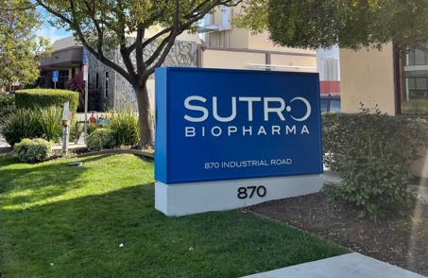
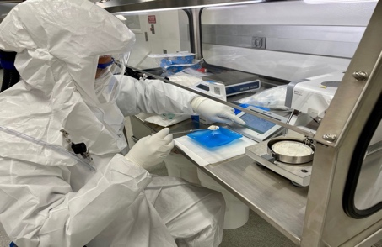
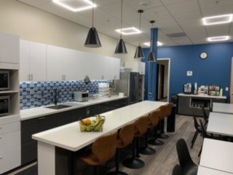
the San Francisco Bay Area.
Ground Transportation
Welcome to Sutro Biopharma
Manufacturing Office
We currently have two locations in
The most efficient mode of
transportation to the
Premium Hotel

This guide provides you with beneficial information for your visit

Sutro Biopharma Corporate Office

Sutro Biopharma Manufacturing Office

Location and Address Manufacturing Office:
Sutro Biopharma 870 Industrial Road
San Carlos, CA 94070 USA

Phone: 650-392-8412
Fax: 650-553-9659
E-Mail: Visitors@sutrobio.com

Traveling by Plane
San Francisco International Airport which is located approx. 12 miles from Sutro San Carlos via Highway 101 South.
manufacturing office are Uber, Lyft and Taxis.

Driving Directions
Whether you’re coming northbound or southbound you will have immediate access to Sutro from US-101 Freeway to Holly Street in San Carlos. Take exit 411 from US-101, then take Industrial Road. Other transit options include direct shuttle service to San Carlos station.
The parking lot located at 870 Industrial Road is free and available to all.

Nearby Restaurants
Chipotle – Mexican

Falafel Tazah – Mediterranean cuisine

Marsha’s Lunchbox – Deli sandwiches

Osteria at Dominica – Italian cuisine

Rustic House – Oyster Bar and grill

Salt + Brine – Modern café, coffee bar, casual dining room and lounge

Starbucks – Coffee bar, fresh salads, sandwiches and snacks.

The Refuge – Casual dining (known for their custom-trimmed by hand pastrami).

Wing Stop – Buffalo-style chicken wings, fries and sides.
Grand Bay Hotel
223 Twin Dolphin Drive Redwood City, CA 94065 Phone: (650) 598-9000
Hotel Recommendations
Approx. 6 min drive to Sutro San Carlos (1.7 miles)

Comfort Hotels

Residence Inn by Marriott 800 East San Carlos Avenue San Carlos, CA 94070 Phone: (650) 637-5500
Approx. 10 min walking distance to Sutro San Carlos (0.5 miles)

Homewood Suites by Hilton 1201 Shoreway Rd
Belmont, California, 94002
Phone: (650) 597-2000
Approx. 7 min drive to Sutro San Carlos (2.3 miles)

Quick COVID-19 Guide
All visitors must be vaccinated and must wear a N95, KN95, or equivalent mask at all times while onsite at Sutro facilities. Face masks are available at the front lobby table. For more information, please visit COVID-19 Visitor Policy

